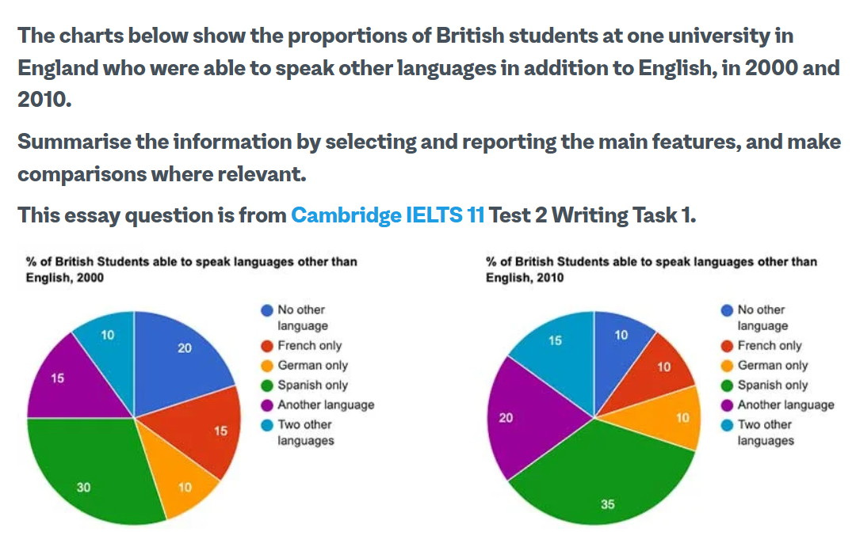

These given pie charts give information about the percentage of students who were able to speak other languages in addition to English in 2000 and 2010.
Overall, we can see that majority of students could speak another language other than English and the number of these students went up during the given 10-year period, from 2000 to 2010.
As it can be seen from the supplied pie charts, most students could speak Spanish. they accounted for 30 percent in 2000 and with a slight increase, they reached 35 percent in 2010. On the other hand, the percentage of students who could not speak any other language except English declined from the fifth of the whole population in 2000 to one in ten in 2010. One in ten could speak German in 2000, remaining constant up to 2010. It is also evident that slightly more than one in ten could speak French, reaching 15 percent in 2010. The last comparison is held for students who could speak one or two other languages, accounting for 25 percent collectively in 2000. This figure grew to slightly more than a third of students in 2010.

